**SRS for Simple Airline Management System**

**1.Objective**

**.Airline Reservations Systems contain airline schedules, fare tariffs, passenger reservations and ticket records.**

**.From the viewpoint of the airline –**

**.Minimize repetitive work done by the system administrator and reservation.**

**.Maintain consistency for the customer for accessing the ARS.**

**.Increases the revenue for ARS in fewer spans of time as more and user can use.**

**. Easy to use, learn and manage the ARS**.

**2.Scope**

**..This Airline Reservation system will work in administration and ticket reservation department in an Airline Company.**

**..The name of the software is “AIRLINE RESERVATION SYSTEM”.**

**. This software provides options for viewing different flights available with different timings for a particular date and provides customers with the facility to book a ticket, modify or cancel a particular reservation but it does not provide the customers with details of cost of the ticket and it does not allow the customer to modify particular part of his reservation and he/she can modify all his details.**

**3. Application Functionality:**

**Mobile check-in**

**By keying on a website on the browser of the mobile phone or downloading a specialized application, you can access the check-in function. Then the method is comparable to what one would expect when using a personal computer to check-in.**

**Some airlines give a mobile boarding pass to a mobile device that can be checked at the airport during safety checks and boarding at the end of the portable check-in cycle. Others, however, send a barcode electronic confirmation that can be submitted to the employees at check-in or checked at the kiosks to the check-in process**.

**Avoiding few features**

**Some of the applications ask its customers to register first which means a form where one has to fill details that is a time-consuming task. In the internet world, everyone wants fast service, avoid adding such features. Your users should be able to make a quick booking regardless of a new customer or an old one.**

**Avoiding cyber crimes**

The more digitized the world is becoming the more we need to be careful. With the quantity of internet presence, cyber dangers have also increased. Ensure that you use the best available technologies to provide the best safety you need.

**4. Application User**

**Since it is based on an online application.The particular can perform the following oeprations:**

**User**

**1.User can log in to website from anywhere**

**2.User can access its account by giving his/her username and password.**

**3.After accessing the application User can book as per his/her requirements to travel .**

**4.User can also book his/her food for an on-way journey from his/her own device(mobile or laptop).**

**5.User can perform security check and get the boarding pass online itself.**

**Admin**

**1.Admin can manage and add the records.**

**2.Admin can search the record of a particular passenger in records.**

**3.Admin can remove the record of passengers.**

**5.E-R DIAGRAM**

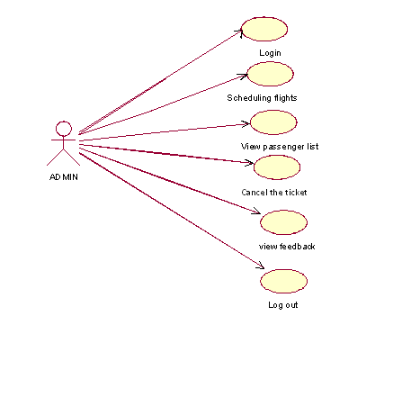

**6. Database Design**

**A.for Login Credentials**

|  |  |
| --- | --- |
| **Username** | **Password** |
| hr | hr |

**B.for Passenger Information**

|  |  |  |
| --- | --- | --- |
| **Passenger ID** | **Patssenger Name** | **Flight no** |
| P-001 | Ajit | 20 |

**C.for Booking Information**

|  |  |  |  |
| --- | --- | --- | --- |
| **Book_Id** | **Starting** | **Destination** | **Passenger Id** |
| B-01 | Pune | Agra | P-001 |
| B-02 | Pune | Delhi | P-002 |

**D.Food order Services**

|  |  |  |
| --- | --- | --- |
| **Airlines** | **Food type** | **Travel** |
| Indigo | Non-veg | Economy |
|  |  |  |

**E.Seat Confirmation**

|  |  |  |
| --- | --- | --- |
| **Confirmation**  **(Yes/No)** | **Destination** | **Mobile number** |
| Yes | Agra | 8308771942 |

**7.Constraints:**

• Primary key Constraints:

ASo we used Primary key to the Passsenger ID in Passenger Table for unique identification.

Also the primary key has been applied to the book_id in booking Table for avoiding the same or duplicate entries.

• Not Null Constraints:

.So we used the Not Null Constraint to the Passenger Id in Passenger table such that the field always contains some record.

.Also the Not Null constraint has been used in the Booking table to the book_id such that it always contains some values.

• Foreign key Constraints:

 So we used Foreign key to the Passenger Id in Booking Table Such that it will refer as Primary key to the Passenger table

.Also we used Foreign key to the book_id in Seat confirmation table such that it will refer as Primary key to the Booking table.

Also we used Foreign key to the seat_no in food order table such that it will refer as Primary Key to the seat_booking.

**8. Functional Requirements**

* Secured Login for System administration.

* . Any administrator/staff can operate on the system. Performing the required task such as adding, searching, updating, removing the details of passengers.

* The passenger information such as Passenger name, passenger Id and flight no is entered into the application system.

* Passenger Check-in- When a new passenger is travelling then the details of the passenger can be easily added into the database.

* Passenger Check-out- When a passenger is ready to leave the starting point(origin) the details of the passenger can be easily deleted or removed from the database.

* Searching can be done by just entering the Passenger Id of Passenger to fetch the passenger details.
* Passenger name details can be easily accessible and can be updated
* easily exit the application just by entering the exit button.

**9.Class Diagram**

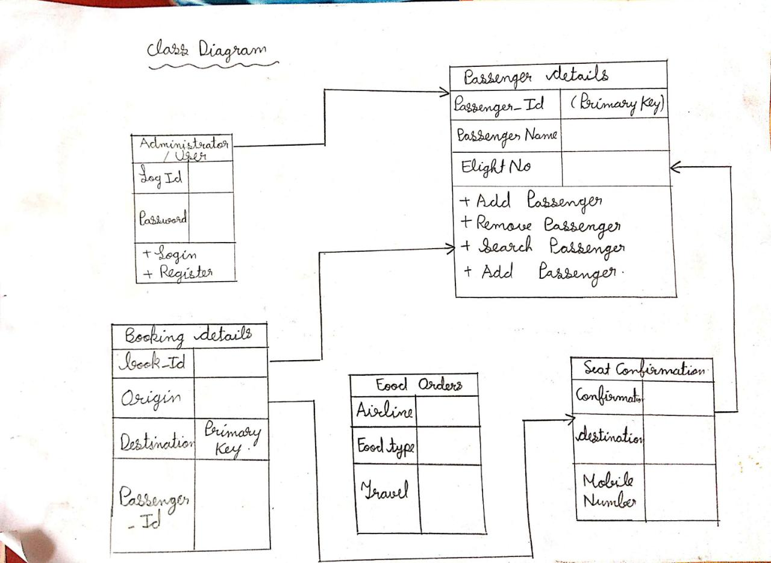

**Java Class Used**

**Domain Object/ Value Object:**

**Purpose of class: To store the user name and password**

|  |  |  |
| --- | --- | --- |
| **Package** | **Class name** | **Methods** |
| com.birlasoft.customerportal.model | LoginVO | Constructor get/set |

**Service Layer:**

**Purpose of class: To validate the Passenger details**

|  |  |  |
| --- | --- | --- |
| **Package** | **Class name** | **Methods** |
| com.birlasoft.customerportal.service | LoginBO/LoginService | Public Boolean validate  Login(LoginVO) |
|  |  | Validate the login credentials base on business logic |

**Data Access Layer:**

**Purpose of class: verify the Login credentials in database**

|  |  |  |
| --- | --- | --- |
| **Package** | **Class name** | **Methods** |
| com.birlaosft.customerportal.dao | LoginDAO | Public boolean checkLogin(LoginVO) |
|  |  | Verify username and password in data base |

**Purpose of class: To store the username and password**

|  |  |  |
| --- | --- | --- |
| **Package** | **Class name** | **Methods** |
| com.birlasoft.customerportal.dao | Connection DB | LoadDrivers() getConnection() closeConnection() |
|  |  | Create database connection |

**Purpose of class: To handle the database exceptions**

|  |  |  |
| --- | --- | --- |
| **Package** | **Class name** | **Methods** |
| com.birlasoft.customerportal.dao | LoginDatabaseException | constructors |

**10.Class diagram**

**A.for removing a record**

Admin/

staff Login

Valid

Login

Add

Passenger

D details

Request

for

Search

ing records

Fetched

from

Database

Passenger record

Se added

Successfully

Admin /

Staff

Airportl Desk

Database

**B.For Searching a Record**

Admin/

staff Login

Valid

Login

Search

Passenger

D details

Request

for

Search

ing records

Fetched

from

Database

Passenger record

Search

Successfully

Admin /

Staff

Airportl Desk

Database

**C.For Update a Record**

Admin/

staff Login

Valid

Login

Update Passenger Details

Request

for

Updat

ing records

Updated

from

Database

Passenger record Updated

successfully

Admin /

Staff

Airportl Desk

Database

**D.for Adding a Record**

Admin/

staff Login

Valid

Login

Add Pas

denger

Details

Request

for

Updat

ing records

Updated

from

Database

Passenger Record Added Succesfully

Admin /

Staff

Airportl Desk

Database